# SoapUI Document

SoapUI official site document – 2019.5.2 14:26 PM

# Managing Requirements

NOTE: This page contains information on standalone SoapUI Pro that has been replaced with ReadyAPI. To try the new functionality, feel free to download a SoapUI Pro trial from our web site.

## Requirements

SoapUI Pro adds basic requirements management to its-feature allowing you to manage system requirements and link them to functional TestCases in your project. Access this feature by opening and double-clicking a project and selecting the “Requirements” tab:

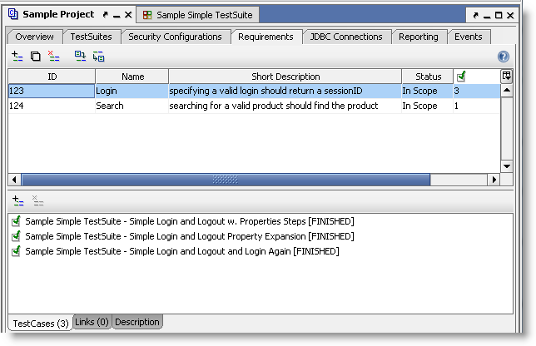

The table and toolbar at the top allow you to add and edit as many requirements as needed, when selecting a requirements the three tabs at the bottom of the window allow you to associate TestCases, external resources (via the Links tab) and a lengthy description with the requirement.

Add a TestCase to a requirement either with the corresponding toolbar or by simply dragging it from the project navigator into the TestCases list. Double-click a TestCase in the list to open its editor window directly.

In the TestCase editor window, a “TestCase Requirement” tab is available showing which requirements that have been mapped to the TestCase:

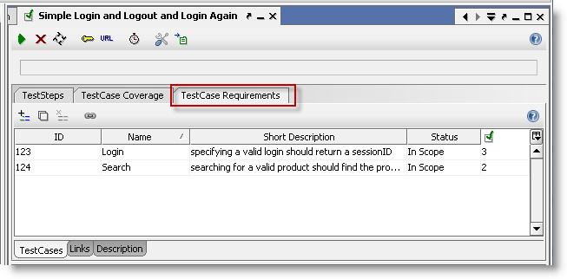

When executing functional TestCases in SoapUI, their latest execution status is shown in the project-level table of requirements and when creating a corresponding test report, a section showing the applicable requirements and the stats of their mapped TestCase is shown:

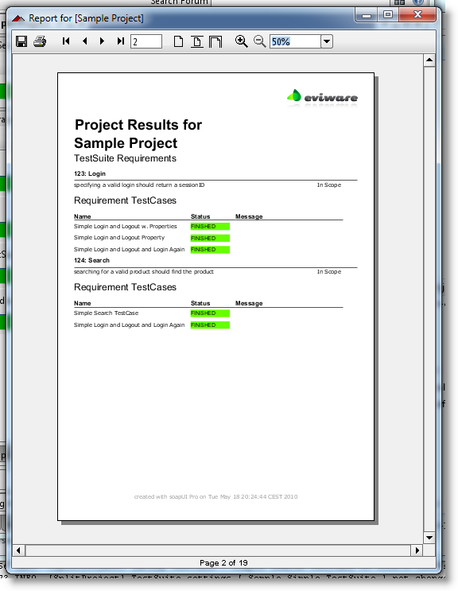

Here we can see our two requirements and that their corresponding TestCases finished OK during the execution of our tests.

## Importing and exporting Requirements

The Requirements Tab at the project level described above allows for both exporting importing requirements from an external system via a csv-file that contains the following columns for each requirement:

* ID
* Name
* Short Description
* Status
* ‘###’ separated list of linked TestCase names
* ‘###’ separated list of associated links
* Long description where line breaks have been replaced with <br/>

For example when exporting the above requirements the file contents are as follows

